Scenario: You are the new Safety Manager

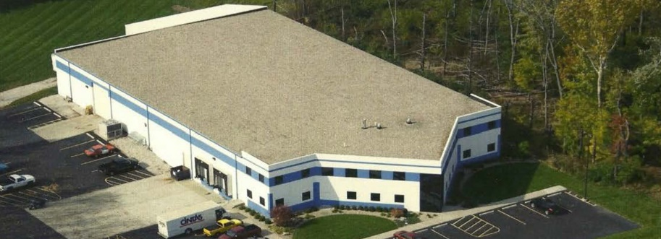

Tri Aerospace LLC – Terre Haute, Indiana

Introduction
Tri Aerospace manufactures a variety of hi-tech composite components for the US Defense Department. The parts are used in classified products of unknown purposes and are assembled at a different secret facility. At the Terre Haute facility Tri has 300 employees. The facility produces $100 million in sales annually. The major goal for the year is to double their current profit margin of 2.5%.
Mr. Warren Hubbel is the General Manager and is the supervisor for the departmental managers: Mr. Ted Smith, Assembly Dept., Ms. Alice Jones, Molding Dept., and Mr. Jake Jackson, Maintenance Dept. Ms. Joan Black is the Human Resources Dept. (HR) manager. Ms. Kerrie Smythe is the office manager for the front office and executive secretary for Mr. Hubbel.
2016 Estimated Direct & Indirect Accident Costs
First Four Months FY16:
8 lost time cases x $27,000/case | = $216,000
16 nonlost time cases x $7,000 | = $112,000
 | $328,000
Estimated direct loses for year: | $984,000
Sales needed to pay for loses would range from between $3.9 to $9.8 million based on a profit margin of 2.5% and the amount of the indirect costs which impact the bottom line on a dollar for dollar basis. Interest lost on $ in reserves - $81,000 per year based on 4.5%
The 2013 OSHA total injury and illness case rate for the plant was 22.2, with a lost workday injury and illness (LWDII) rate of 8.1. Year to date in 2013, 24 recordables have occurred with 8 lost-time cases. This places the company on pace with last year's performance, projecting rates of 17.6 and 7.8. The BLS rates for their industry are 12.5 and 6.6 respectively (SIC 3069).
The company just hired their first safety manager, YOU. You report directly to the Human Resources manager, Ms. Black. Today is your first day on the job. Congratulations!!!! Up to now all safety responsibilities have been shared by the safety committee. The safety committee is comprised of all the managers and Ms. Smythe. After receiving an initial orientation from Ms. Black you were informed of high expectations that she and the plant manager had for you, i.e., 50% reduction in rates in the next year and OSHA VPP Star Certification in 2 years. You sit down at your new desk and begin to examine several 2013 safety related documents, the OSHA 300 log, safety incidence reports, and copies of the safety committee minutes. Your task at this time is to come up with an action plan to meet the plant manager's expectations. Ms. Black has asked for the action plan in two weeks, so that she can present it to Mr. Hubbel. What do you do?
Instructions:

Given the above scenario with you in the role of the new Safety Manager, develop your plan for achieving management’s safety and health objectives for Tri Aerospace LLC. Use the resources provided in Blackboard>SFTY 416>Supplemental Learning Resources folder plus any other resources you may find useful.

- Your final product will be your written plan for achieving Mr. Hubbel’s vision for safety excellence. Your plan should be in a format that can be presented to Ms. Black who will then present it to Mr. Hubbel. You may use PowerPoint or other presentation applications to supplement your written plan.
- Submit your presentation in Turnitin.

Be certain to cite your sources.

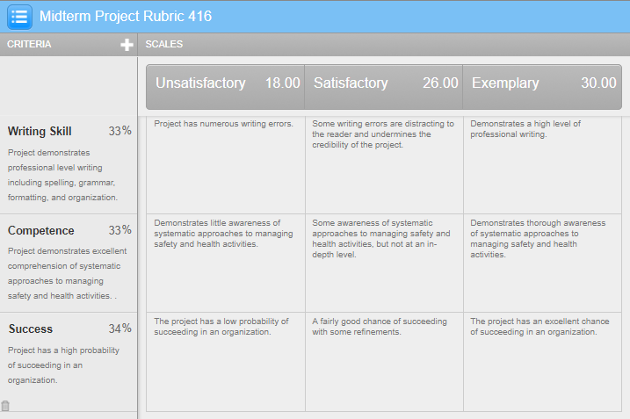
Grading Rubric

